How to read more than 1024 sources from a meter
Take the PMC-660 meter for example:
- Divide the PMC-660_V1.1.snf file into three SNF files: PMC-660_V1.1-1.snf, PMC-660_V1.1-2.snf, PMC-660_V1.1-3.snf.
- Start PecConfig. Add three devices under the same site, the communication parameters for the three devices are exactly the same, such as ID, Baud rate...
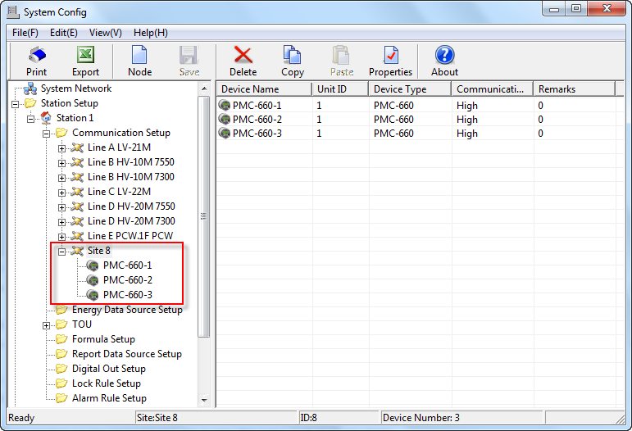
- Import the SNF file to each device sequentially, that is, import PMC-660_V1.1-1.snf to device PMC-660-1, import PMC-660_V1.1-2.snf to device PMC-660-2, import PMC-660_V1.1-3.snf to device PMC-660-3.
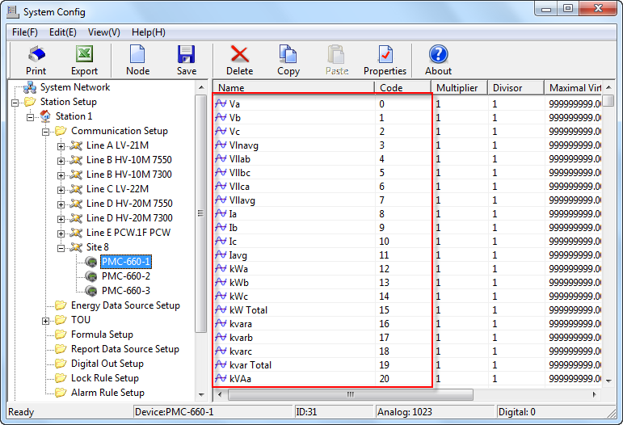

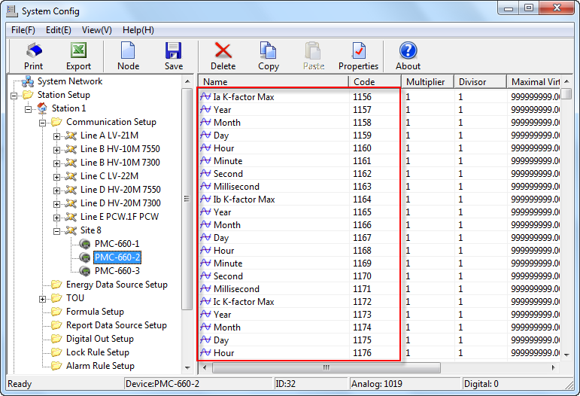

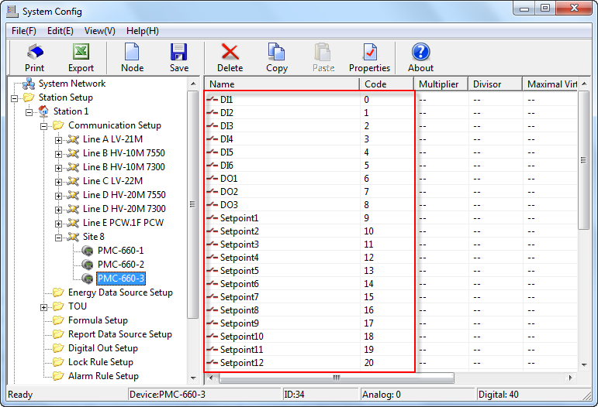
- Save the configurations to the database.
- Start PecSCADA. Check the readings from each device.
